C++ Interview Questions

1. What is C++?

- C++ is an object-oriented programming language that was introduced to overcome the jurisdictions where C was lacking.
- By object-oriented we mean that it works with the concept of polymorphism, inheritance, abstraction, encapsulation, object, and class.

2. What are the advantages of C++?

- C++ is an OOPs language that means the data is considered as objects.
- C++ is a multi-paradigm language; In simple terms, it means that we can program the logic, structure, and procedure of the program.
- Memory management is a key feature in C++ as it enables dynamic memory allocation
- It is a Mid-Level programming language which means it can develop games, desktop applications, driv
- ers, and kernels.

3. What are references in C++?

- A referenced variable is another named variable of an existing variable keeping in mind that changes made in the reference variable will be reflected in the already existing variable.
- A reference variable is preceded with a ‘&’ symbol.

4. Define a token in C++.

- A token is the smallest individual element of a program that is understood by a compiler. A token comprises the following:

- Keywords – That contain a special meaning to the compiler
- Identifiers – That hold a unique value/identity
- Constants – That never change their value throughout the program.

5. Difference between call by value and call by reference.

Call by Value | Call by Reference
A copy of a variable is passed. | A variable itself is passed fundamentally.
Calling a function by sending the values by copying variables. | Calling a function by sending the address of the passed variable.
The changes made in the function are never reflected outside the function on the variable. In short, the original value is never altered in Call by Value. | The changes made in the functions can be seen outside the function on the passed function. In short, the original value is altered in Call by reference.
Passed actual and formal parameters are stored in different memory locations. Therefore, making Call by Value a little memory insufficient | Passed actual and formal parameters are stored in the same memory location. Therefore, making Call by Reference a little more memory efficient.

6. What is the difference between C and C++?

C | C++
It is a procedural programming language. In simple words, it does not support classes and objects | It is a mixture of both procedural and object-oriented programming languages. In simple words, it supports classes and objects.
It does not support any OOPs concepts like polymorphism, data abstraction, encapsulation, classes, and objects. | It supports all concepts of data
It does not support Function and Operator Overloading | It supports Function and Operator Overloading respectively
It is a function-driven language | It is an object-driven language

In procedural programming, the program is divided into small parts called functions. | In object-oriented programming, the program is divided into small parts called objects.

Procedural programming does not have any proper way of hiding data so it is less secure. | Object-oriented programming provides data hiding so it is more secure.

7. What is the difference between struct and class?

Struct | Class
Members of the struct are always by default public mode | Members of the class can be in private, protected, and public modes.
Structures are of the value type. They only hold value in memory. | Classes are of reference type. It holds a reference of an object in memory.
The memory in structures is stored as stacks | The memory in classes is stored as heaps.

8. What is the difference between new and malloc()?

new | malloc()
new is an operator which performs an operation | malloc is a function that returns and accepts values
new calls the constructors | malloc cannot call a constructor
new is faster than malloc as it is an operator | malloc is slower than new as it is a function
new returns the exact data type | malloc returns void*

9. What is the difference between virtual functions and pure virtual functions?

Virtual Function | Pure Virtual Function
A Virtual Function is a member function of a base class that can be redefined in another derived class. | A Pure Virtual Function is a member function of a base class that is only declared in a base class and defined in a derived class to prevent it from becoming an abstract class.
A virtual Function has its definition in its respective base class. | There is no definition in Pure Virtual Function and is initialised with a pure specifier (= 0).
The base class has a virtual function that can be represented or instanced; In simple words, its object can be made. | A base class having pure virtual function becomes abstract that cannot be represented or instanced; In simple words, it means its object cannot be made.  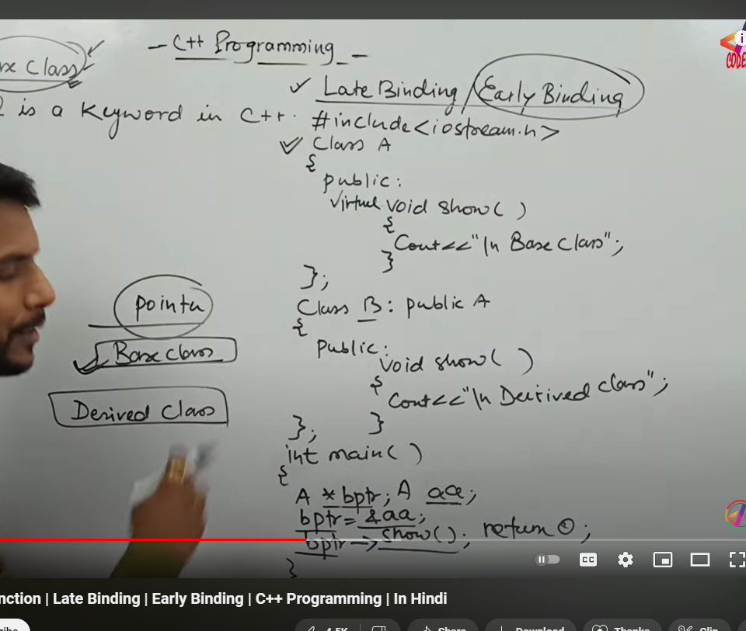  B class ka object b k show ko call krega ue funciton hai virtual ka  Pure virtual means no defination  This is called late binding  Opposite is called early binding  Virtual function helps in run time polymorphism

10. What is virtual inheritance?

- Virtual inheritance is a technique that ensures only one copy of a base class’s member variables is inherited by grandchild-derived classes.
- In simple terms, virtual inheritance is used when we are dealing with a situation of multiple inheritances but want to prevent multiple instances of the same class from appearing in the inheritance hierarchy.

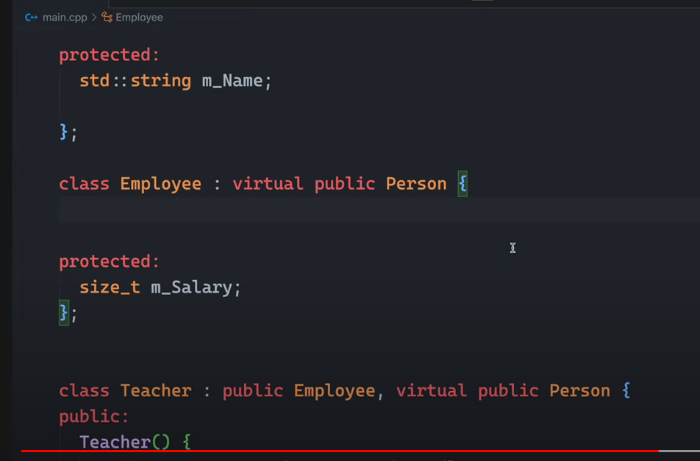

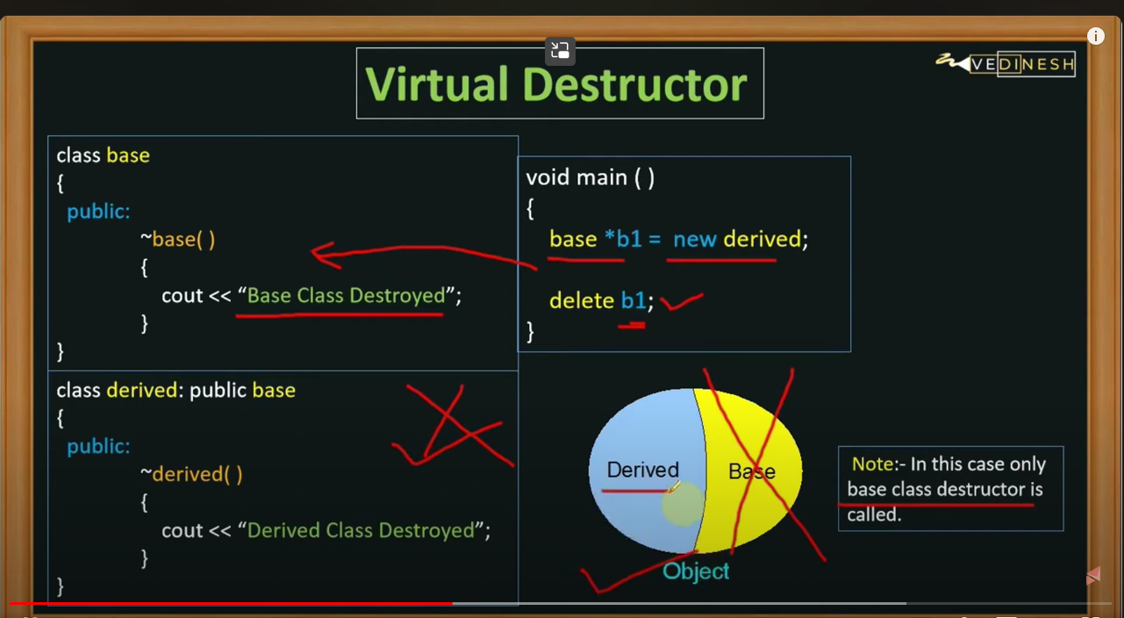
So make destructor as virtual
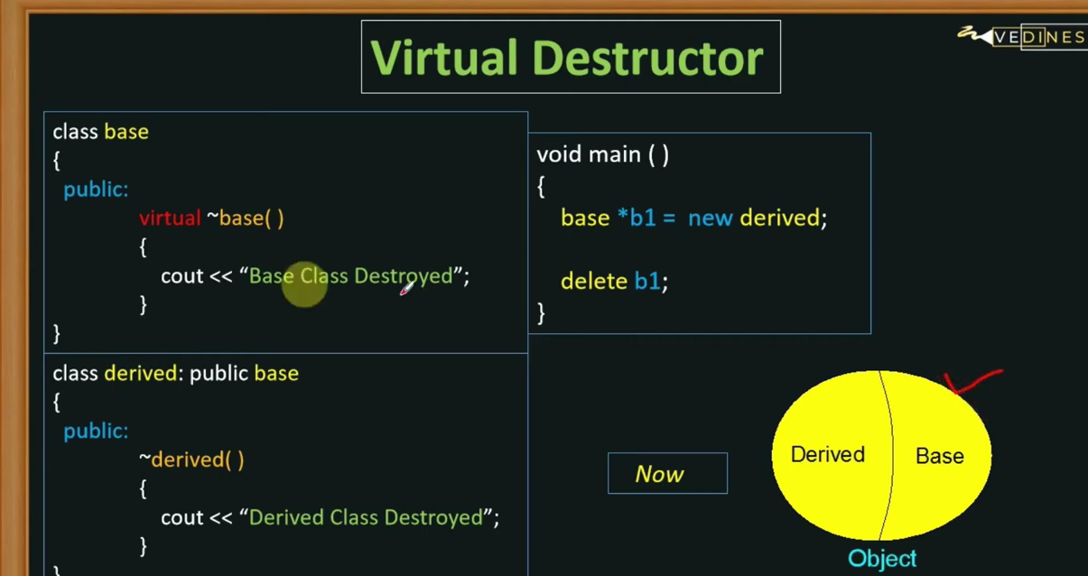

11. What is a virtual destructor?

- When destroying instances or objects of a derived class using a base class pointer object, a virtual destructor is invoked to free up memory space allocated by the derived class object or instance.
- Virtual destructor guarantees that first the derived class’ destructor is called. Then the base class’s destructor is called to release the space occupied by both destructors in the inheritance class which saves us from the memory leak.
- It is advised to make your destructor virtual whenever your class is polymorphic.

12. Is destructor overloading possible? If yes then explain and if no then why?

The simple answer is NO we cannot overload a destructor. It is mandatory to only destructor per class in C++. Also to mention, Destructor neither takes arguments nor they have a parameter that might help to overload.

13. Which operations are permitted on pointers?

Pointers are the variables that are used to store the address location of another variable. Operations that are permitted to a pointer are:
- Increment/Decrement of a Pointer
- Addition and Subtraction of integer to a pointer
- Comparison of pointers of the same type

14. What is the purpose of the “delete” operator?

The delete operator is used to delete/remove all the characteristics/properties from an object by deallocating its memory;
Furthermore, it returns true or false in the end.
In simple terms, it destroys or deallocates array and non-array(pointer) objects which are created by new expressions.

int GFG = new int[100];
// uses GFG for deletion
delete[] GFG;

15. What does the Scope Resolution operator do?

- A scope resolution operator is denoted by a ‘::‘ symbol. Just like its name this operator resolves the barrier of scope in a program.
- A scope resolution operator is used to reference a member function or a global variable out of their scope furthermore to which it can also access the concealed variable or function in a program. Scope Resolution is used for numerous amounts of tasks:
  - To access a global variable when there is a local variable with the same name
  - To define the function outside the class
  - In case of multiple inheritances
  - For namespace

16. What is an abstract class and when do you use it?

- An abstract class is a class that is specifically designed to be used as a base class. An abstract class contains at least one pure virtual function.
- You declare a pure virtual function by using a pure specifier(= 0) in the declaration of a virtual member function in the class declaration.
- You cannot use an abstract class as a parameter type, a function return type, or the type of an explicit conversion, nor can you declare an object of an abstract class.
- However, it can be used to declare pointers and references to an abstract class.
- An abstract class is used if you want to provide a common, implemented functionality among all the implementations of the component. Abstract classes will allow you to partially implement your class, whereas interfaces would have no implementation for any members whatsoever.
- In simple words, Abstract Classes are a good fit if you want to provide implementation details to your children but don’t want to allow an instance of your class to be directly instantiated.

17. What is ‘this‘ pointer in C++?
Hidden
- this pointer enables every object to have access to its own address through an essential pointer.
- All member functions take this pointer as an implicit argument. this pointer may be used to refer to the calling object within a member function.
- this pointer is used to pass an object as a parameter to another method. Each object gets its own copy of the data member.
- this pointer is used to declare indexers.

18. What is the difference between a deep copy and shallow copy?

Shallow Copy | Deep Copy
In Shallow copy, a copy of the original object is stored and only the reference address is finally copied. In simple terms, Shallow copy duplicates as little as possible | In Deep copy, the copy of the original object and the repetitive copies both are stored. In simple terms, Deep copy duplicates everything
A shallow copy of a collection is a copy of the collection structure, not the elements. With a shallow copy, two collections now share individual elements. | A deep copy of a collection is two collections with all of the elements in the original collection duplicated.
A shallow copy is faster | Deep copy is comparatively slower.

Static function variabekl

Employee {
Public:
Static int count ;
Class variable

